Write a C program to enter n elements (n value entered by user) in a 1D array and print the

summation of all elements of the array.

#include <stdio.h>

void main()

{

    int n, sum = 0;

    printf("Enter number of elements in array\n");

    scanf("%d", &n);

    int arr[n];

    printf("Enter the elements of the array\n");

    for (int i = 0; i < n; i++)

        scanf("%d", &arr[i]);

    for (int i = 0; i < n; i++)

        sum = sum + arr[i];

    printf("The sum of the elements of the array is %d\n", sum);

}

Output

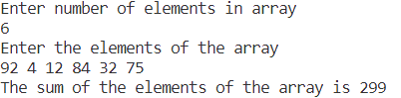

Write a C program to enter n elements (n value entered by user) in a 1D array and search for a required element in the 1D array. Print the location of the search element and if element not found print “Element not found message”

#include <stdio.h>

void main()

{

    int n, num, flag = 0;

    printf("Enter number of elements in array\n");

    scanf("%d", &n);

    int arr[n];

    printf("Enter the elements of the array\n");

    for (int i = 0; i < n; i++)

        scanf("%d", &arr[i]);

    printf("Enter the element to be searched\n");

    scanf("%d", &num);

    for (int i = 0; i < n; i++)

    {

        if (arr[i] == num)

        {

            printf("%d found at %d\n", num, i + 1);

            flag = 1;

            break;

        }

    }

    if (flag == 0)

        printf("Element not found\n");

}

Output

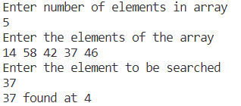

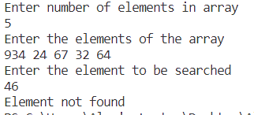

Write a C program to compare two 1D array’s, print if both array elements are the same or not.

#include <stdio.h>

void main()

{

    int n, m, flag = 0;

    printf("Enter number of elements in first array\n");

    scanf("%d", &n);

    int arr1[n];

    printf("Enter the elements of the first array\n");

    for (int i = 0; i < n; i++)

        scanf("%d", &arr1[i]);

    printf("Enter number of elements in second array\n");

    scanf("%d", &m);

    int arr2[m];

    printf("Enter the elements of the first array\n");

    for (int i = 0; i < m; i++)

        scanf("%d", &arr2[i]);

    if (n == m)

    {

        for (int i = 0; i < n; i++)

        {

            if (arr1[i] != arr2[i])

            {

                printf("Elements at %d are different\n", i + 1);

                flag = 1;

                break;

            }

        }

    }

    else

        printf("Arrays have dissimilar lenghts\n");

    if (flag == 0)

        printf("Both arrays have same elements\n");

}

Output

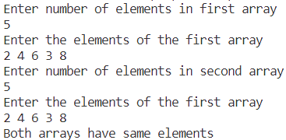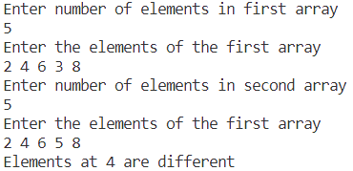

Write a C program to enter n elements (n value entered by user) in a 1D array, count the number of prime numbers in the array and print the same.

#include <stdio.h>

void main()

{

    int n, count = 0, flag = 0;

    printf("Enter number of elements in array\n");

    scanf("%d", &n);

    int arr[n];

    printf("Enter the elements of the array\n");

    for (int i = 0; i < n; i++)

        scanf("%d", &arr[i]);

    for (int i = 0; i < n; i++)

    {

        for (int j = 2; j < arr[i]; j++)

        {

            if (arr[i] % j == 0)

            {

                flag = 1;

                break;

            }

        }

        if (flag == 0)

            count++;

        flag = 0;

    }

    printf("Number of prime numbers in the array: %d\n", count);

}

Output

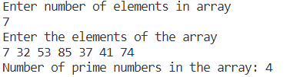

Write a C program to reverse the elements of a 1D array

#include <stdio.h>

void main()

{

    int n, temp;

    printf("Enter number of elements in array\n");

    scanf("%d", &n);

    int arr[n];

    printf("Enter the elements of the array\n");

    for (int i = 0; i < n; i++)

        scanf("%d", &arr[i]);

    for (int i = 0; i < (n / 2); i++)

    {

        temp = arr[i];

        arr[i] = arr[n - i - 1];

        arr[n - i - 1] = temp;

    }

    printf("The reversed array is\n");

    for (int i = 0; i < n; i++)

        printf("%d ", arr[i]);

}

Output

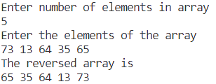

Write a C program to delete an element from a 1D array. Shift all the remaining elements one position to the left of the deleted element

#include <stdio.h>

void main()

{

    int n, num;

    printf("Enter number of elements in array\n");

    scanf("%d", &n);

    int arr[n];

    printf("Enter the elements of the array\n");

    for (int i = 0; i < n; i++)

        scanf("%d", &arr[i]);

    printf("Enter the element you want to delete: ");

    scanf("%d", &num);

    for (int i = 0; i < n; i++)

    {

        if (arr[i] == num)

        {

            for (int j = i; j < (n - 1); j++)

                arr[j] = arr[j + 1];

            break;

        }

    }

    printf("The edited array is\n");

    for (int i = 0; i < (n - 1); i++)

        printf("%d ", arr[i]);

}

Output

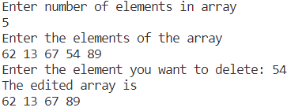

Write a C program to find the second largest element in a 1D array and print the same

#include <stdio.h>

void main()

{

    int n;

    printf("Enter number of elements in array\n");

    scanf("%d", &n);

    int arr[n];

    printf("Enter the elements of the array\n");

    for (int i = 0; i < n; i++)

        scanf("%d", &arr[i]);

    int sl = arr[0], l = arr[0];

    for (int i = 1; i < n; i++)

    {

        if (arr[i] > l)

        {

            sl = l;

            l = arr[i];

        }

        else if (arr[i] > sl && arr[i] < l)

            sl = arr[i];

    }

    printf("The second largest element in the array is %d\n", sl);

}

Output

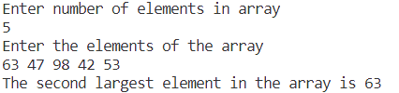

Write a C program to swap the adjacent elements of a 1D array and print the same

#include <stdio.h>

void main()

{

    int n, temp;

    printf("Enter number of elements in array\n");

    scanf("%d", &n);

    int arr[n];

    printf("Enter the elements of the array\n");

    for (int i = 0; i < n; i++)

        scanf("%d", &arr[i]);

    for (int i = 0; i < (n - 1); i = i + 2)

    {

        temp = arr[i];

        arr[i] = arr[i + 1];

        arr[i + 1] = temp;

    }

    printf("The swapped array is\n");

    for (int i = 0; i < n; i++)

        printf("%d ", arr[i]);

}

Output

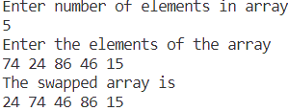

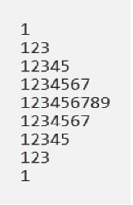

#include<stdio.h>

void main()

{

    int i, j;

    for(i = 1; i <= 9; i=i+2)

    {

        for(j = 1; j <= i; j++)

            printf("%d ", j);

        printf("\n");

    }

    for(i=7; i>0; i = i - 2)

    {

            printf("%d ", j);

        printf("\n");

    }

}

Output

